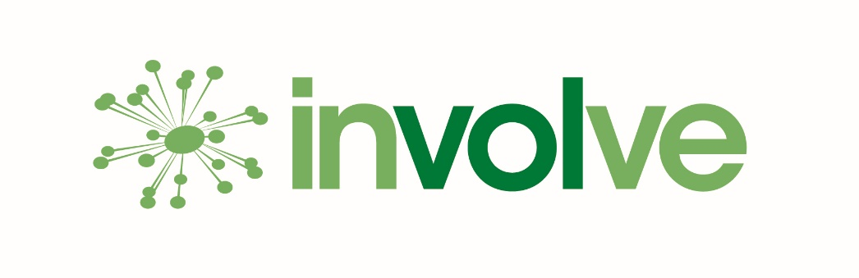
Application form for community funding
Involve Kent are working with Kent County Council to conduct a listening project for residents to reflect on the impact of the COVID-19 Pandemic and related restrictions on their mental health and wellbeing, with a particular focus on hearing from Seldom Heard Communities. We are asking members of the public to share their experiences and stories with us to help shape decisions going forward that accurately reflect the needs of our communities.
As part of this project, we are providing funding of between £250 - £2500 for small projects in communities that fit this description and can support us with this engagement project. We typically engage with people in one of three ways: one to one interviews, group chats or surveys. We would ask you to help us get in touch with members of your community to help with our feedback project.
This application form is for you to let us know why your project needs funding and how it will benefit your community.
Funding from £250 to £2500 is available for community groups who meet the following criteria:
- Your application must come from an established organisation with its own bank account.
- Your organisation must be based and operate in West Kent.
- You must be over 18 to make the application.
- Your project must be planning to support a minimum of 10 people.
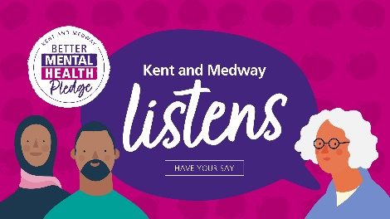
How would your organisation like to participate in this listening project (via any of our methods) to ensure the voice of your community is heard. Please do ask if you would like advice about how to make this happen.

What is the time frame of the application process?
- Application Deadline 28.01.2022, all applications must be received in writing by email to outreachteam@involvekent.org.uk by this date.
- We will respond to you by 04.02.2022
- We will contact you by email to inform you if your application has been successful.
- Funds will be supplied soon after if a positive decision is made.

If successful, we politely request you to give feedback on how the funds have helped your group or project, including providing photos (where appropriate).

If you need any help with your application, please email outreachteam@involvekent.org.uk with details of the type of assistance you require.

Please fill your response to all the questions below:

Name of person making application______________________________________________

Name of organisation_________________________________________________________

Location of organisation_______________________________________________________

Contact information to send response to___________________________________________

Please limit your response to the following questions to a maximum of 200 words.
- Tell us about your organisation.

- Who is this funding going to help support?

- How much funding are you applying for?_______________________________________

- Is the funding you are applying for going to support an existing project or to set up a new initiative? If new, what is the predicted start date?

- Tell us what you plan to use the money for.

- What are you hoping to achieve with this project?

- How many people do you hope to reach with this project? ________________________

- Please provide information on how you believe this project will positively affect the mental wellbeing of the participants.

That’s all for now.
We will be in touch as soon as we decide if your application has been successful.

